## DevOps Process

Introduction

After a meeting with Pat, I was asked to implement a process for Shinty Software to modernise its process. This document brings a seven-step process to help the company get back on its feet.

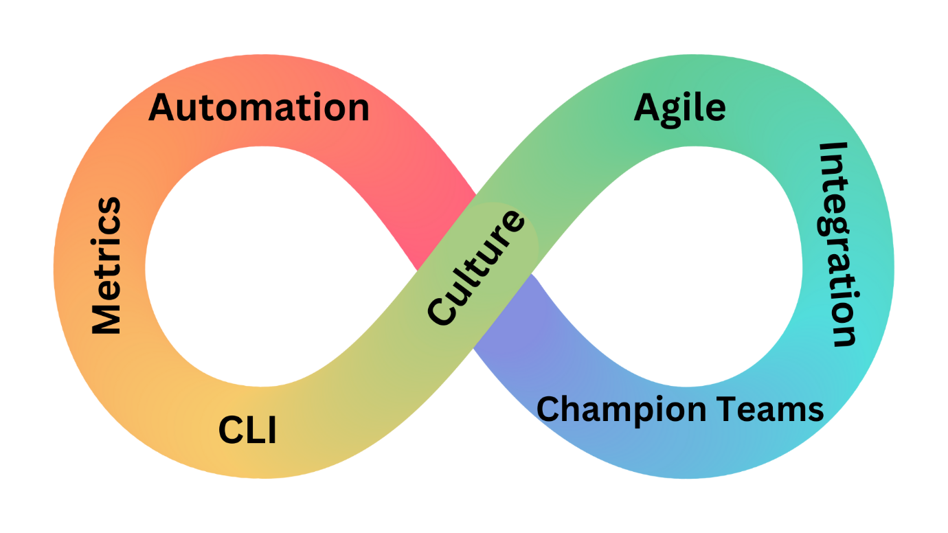

DevOps process brings a series of benefits to the company, such as greater team integration, faster and higher quality deliveries, fewer errors, cost reduction (reduced errors mean less rework cost), and greater employee training. Therefore, to implement a DevOps environment in this company, it is essential that we take all aspects into consideration.

We are going to do this in 7 steps:

1. **Culture**

DevOps is not just a methodology or a strategy, but a culture - consists of a change in the organization's culture and in the way the operations and development areas work. We will start with a culture diagnosis to understand what are the main elements that already exist in the company, and identify what should be modified and what can remain the way it is today.

1. **Agile Methodology**

To complete the first step, it is ideal for executives who hold leadership positions to adopt agile methodologies, allowing for an approach focused on integrating teams and results. The company manager must have the same vision to plan activities focused on results, automation, and integration.

1. **Integration**

The main element of implementing a DevOps environment in the company is exactly the integration between the different areas. This means that it is not enough for them to work communicating with each other, it is essential to ensure that everyone performs their activities effectively together and collaboratively. For this to work, we need to create an efficient communication channel for both teams to interact. Creating strategies together so that the work is carried out in the best possible way.

1. **Empower Team/ Champion Team**

The creation of a team is a step that will always be very relevant because they will be the “agents of change”. All employees need to understand what DevOps is, what the goals and benefits of having this culture are, and how it works in practice. That way, we increase engagement in the process, boosting our chances of success. Therefore, we need to invest in training for the team. This strategy allows each one to understand their role in this environment and be aware of what actions are needed to get this off the ground, engaging in their own activities.

1. **Automation**

The agile methodology needs to be treated from software development cycles with the objective of accelerating processes. That is, the technical part supports people management and vice versa. Processes need to be automated; time must be optimized. Many people manually do some work that if done automatically makes everything simple. This is the key because it helps to deliver in less time and with better final results.

1. **Metrics**

We need to observe the consequences that those new implementations will generate for the company and the results of the new strategy. As such, constantly monitoring performance is critical to maintaining long-term success. We will start with measuring metrics, before and after DevOps. They can be related to the individual performance of employees or the team as a whole, as well as the development time of new products and solutions with quality of results. From there, it is possible to start the performance monitoring process. With those metrics, it becomes easier to control and measure all activities, such as the average time to perform each action, the number of solutions delivered in a given period, and process bottlenecks, among others.

1. **Continuous learning and improvement**

As software follows a continuous integration/delivery process, so do DevOps processes. Over time, teams will learn lessons about how to make something better. These lessons must find their way back to the organization's strategy. New employees will bring new perspectives and past employer experiences and projects. Inevitably, teams will also want to incorporate some of their learnings and experience into the framework of DevOps

To be successful in applying those steps, we need to implement one process/automation, monitor and measure this, and then move on to a second process. For each process or automation applied, all team members have to use it in order to obtain the best benefit. If the team fails to evolve with the improvement, we will reconsider and discard. We won’t keep things that don't bring value to the team.